Seneca College
July 4, 2020

PROJECT PROPOSAL

Change Project delivery method

From Classical Project Management Methodology (Waterfall) to Agile approach (Scrum)

Table of Content
I. Summary 3
II. Introduction 4
III. Needs/Problems 5
IV. Goals/Objectives 5
V. Procedures/Scope of Work 5
VI. Timetable 5
VII. Budget 9
VIII. Key Personnel 9
IX. Evaluation 10
X. Appendix 10

- Summary
At Seneca College, we are always the among the top company that achieve a high result in customer satisfaction and IT product. We always change to bring customer the best benefit they can and should get when working with us. The new change not only save us time on completion of the project but also save our customer resources when they can roll out the product early.
This proposal is written to propose about a change for the next project delivery. Instead of using the classic management methodology of implementing and design the software, the team has decided to try with the new approach and believe this would help cut the time for the project and increase efficiency in deliver project on time with satisfaction from customers.
There will be a few changes required to achieve this. At the first step, areas such as Training, Documentation, Executive Support and Team Management approaches will given trial for the change to see the beginning efficiency. The reason for this is that, while Analysis, Design and Development are very important, those step will only considered for Agile approach only if this trial brings a positive sign to the team.
In order to achieve that, there will be an increase of personnel in these specific department and work section:
- Training: Training personnel
- Documentation: Writer, Analysis, Lawyer
- Executive Support: remain the same, with increasing number of working hours
- Team Management: remain the same, with increasing number of working hours
Because of those change, we can expect from a small increasing in budget to no increasing at all. We cut the duration of the project by hiring more people.

- Introduction
Seneca College has been established in 1967 as a College institution in Toronto, Canada. The school focus on education of some specific field such as Arts, Business and Technology related. As time goes by, Seneca College has proven itself one of the best institution when it comes to IT studies.
Since 2010, the school decided to take part as an IT company, where it will takes order, requirement from customers and build the program. What special about it is that, the project will be working by Seneca students and professor from many different field. Day by day, year by year, Seneca has proven its curriculum qualification by thousands of satisfied customer who came, are coming and will come to Seneca for IT project. Our goal is to create a concept for everyone when they think of Seneca” When you think about an IT project, you think about Seneca.”.

- Needs/Problems
Change of project management methodology from Classical (Waterfall) to Agile (Scrum) method are guarantee to save at least 20% of the time for any project. In this proposal, we are looking to roll-out a trial to see the improvement in progress and efficiency compared to the old classic method. With that, the following task is required to change:
- Allocate team member to shorten the task duration.
- Shorten the time for Documentation (Help and User Manual).
- Shorten the time for Training.
- Enhance support from Executive personel (Manager,…).

- Goals/Objectives
- Shorten the time use to make Documentation (doing front-end, back-end altogether).
- Shorten the time use to Train the customer (doing front-end, back-end altogether).
- Assign Executive to more task to ensure project are stay on track and match with the requirements.
- Procedures/Scope of Work
Provide detailed information about proposed procedures, if available, and the scope of work. Include information on activities such as recruiting, training, testing, and actual work required.
- Hire one more personnel who mainly responsible for Training and Documentation (Trainer and Technical Communicator, respectively).
- Decide some task where task duration can be shorten if additional person work on the task.
- Decide who is responsible for which task throughout the progress (if the task only required one person).
- Take budget into consideration, if the task require a large amount of budget but doesn’t increase efficiency, it could be eliminate.
- Additional personnel only efficient if they are handle the % of work equal or larger than the % of shorten time. (Ex. If plan is to reduce training time by 30%, the additional personnel should handle at least 30% of the entire training task).
- Timetable
Here is the time table of the new schedule vs. the old schedule.
- At Phase One, the new schedule should reduce the time by ~35% compared to the old schedule, allow the rest of the progress to work faster.
- At Phase Two, the new schedule should reduce the time by ~33% compared to the old schedule, allow the rest of the progress to work faster.
 | Description of Work | Start and End Dates
Phase One | Reduce Training Time | Old Date: 13/04 – 24/05 (30)  New Date: 13/04 – 09/05 (19)
Phase Two | Reduce Documentation Time | Old Date: 25/05 – 27/06 (24)  New Date*: 25/05 – 16/06 (16)
*The start date of new and old schedule are the same for comparision purpose. The actual date for new schedule at documentation stage is 10/05 – 25/05
- Gantt Chart of new schedule for Documentation
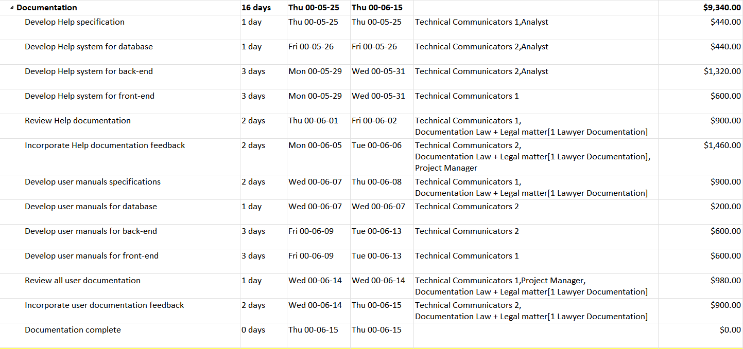

- Resources Usage of new Documentation schedule
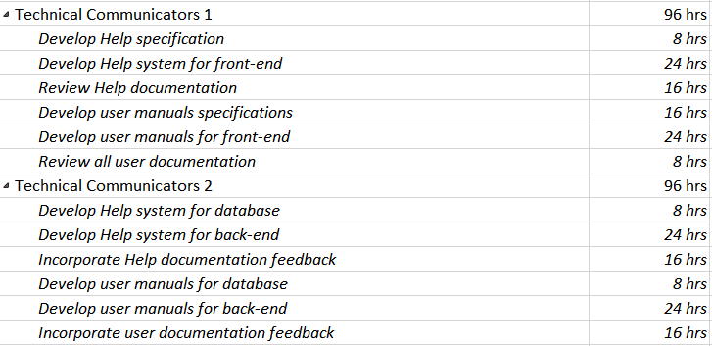
- Gantt Chart of old schedule for Documentation
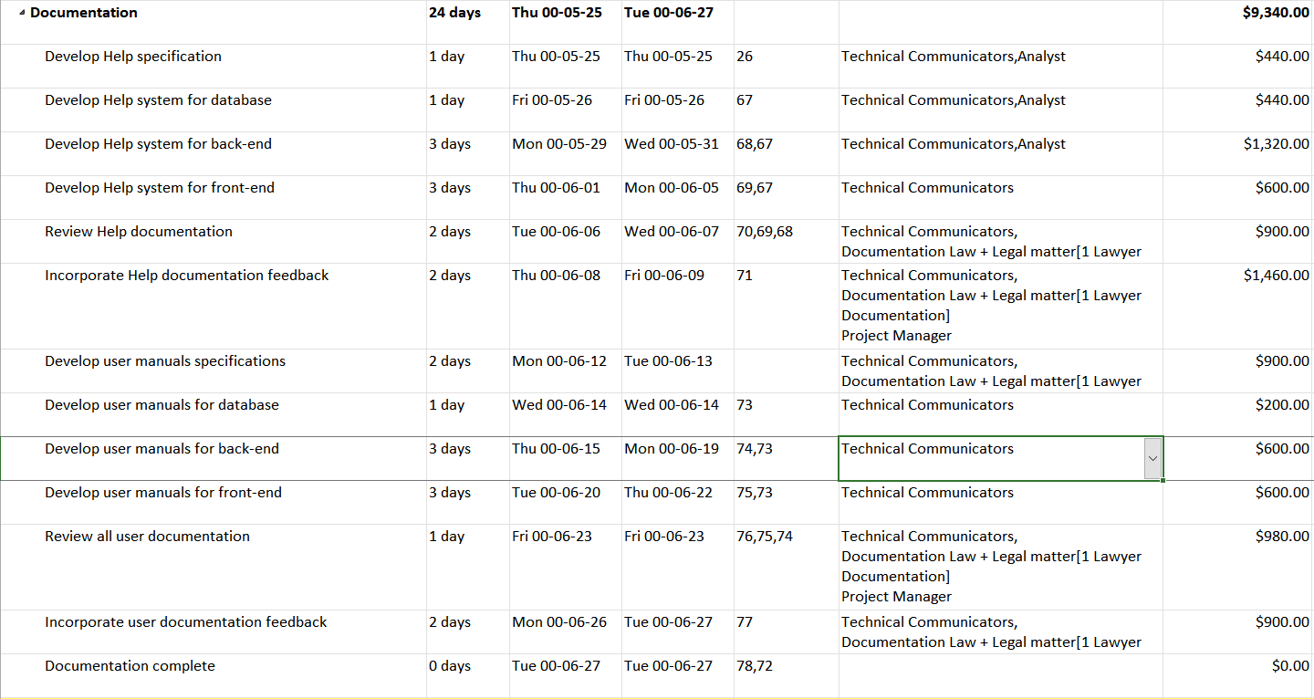
- Resources Usage of old Documentation schedule
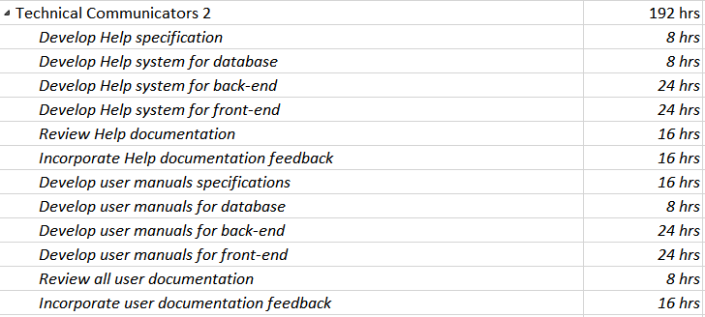
- Gantt Chart of new schedule for Training
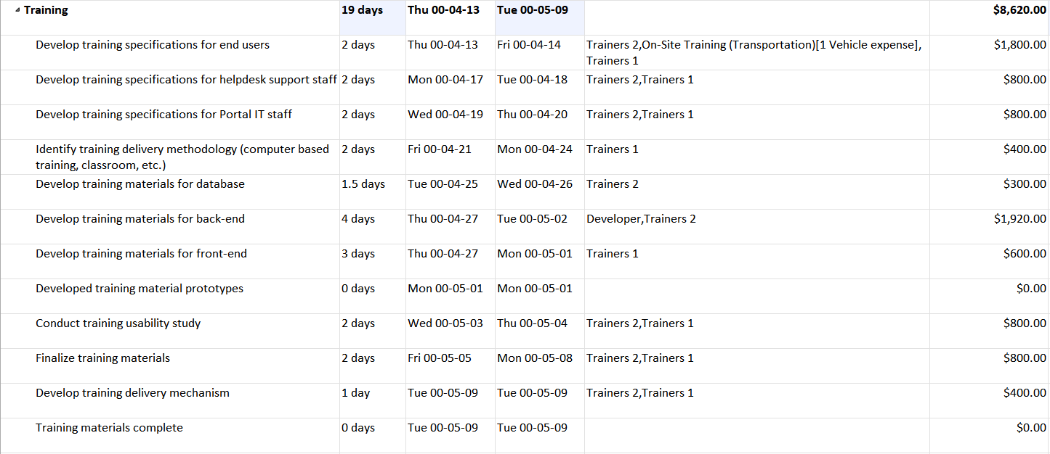
- Resources Usage of new Documentation schedule
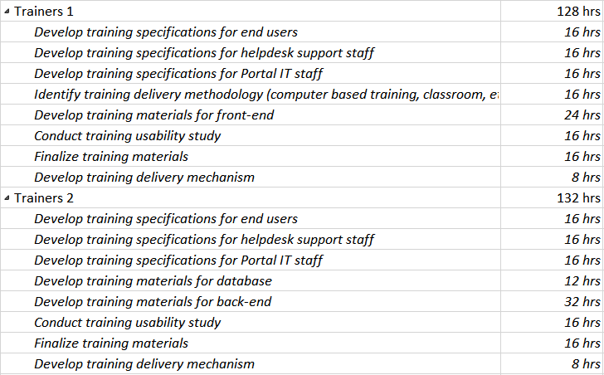
- Gantt Chart of old schedule for Training
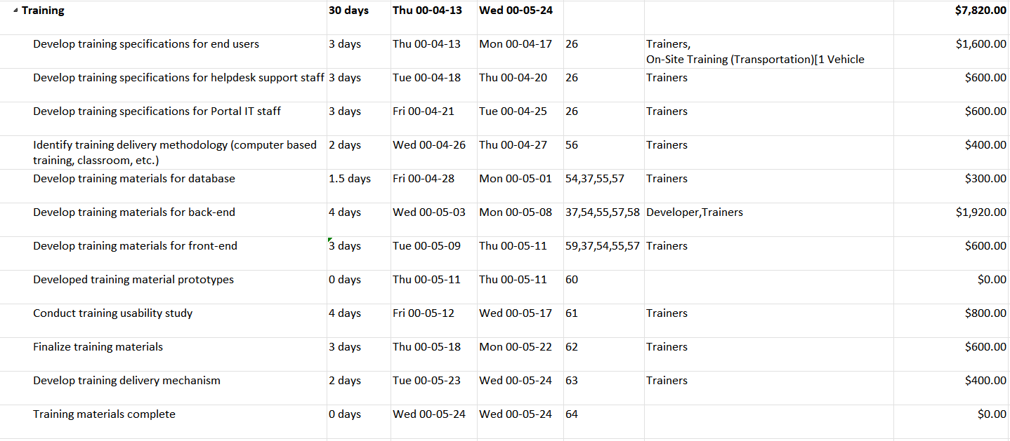
- Resources Usage of old Training schedule
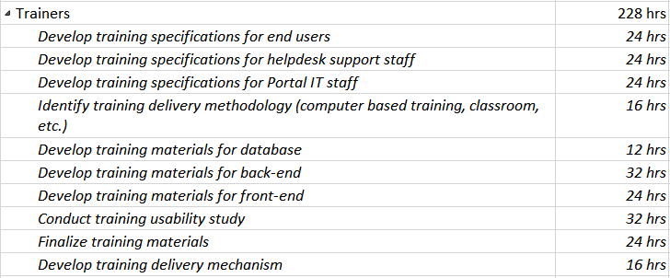

- Budget
 | Description of Work | Start and End Dates
Phase One | Reduce Training Time | Old Budget: $7820,00  New Budget: $8620,00
Phase Two | Reduce Documentation Time | Old Budget: $9340,00  New Budget: $9340.00
 | Total | Old Budget: $17160,00  New Budget: $17960.00
- The estimated budget for the Agile approach is listed as New Budget. With this new budget, we do expect an increase of $800,00 to have an extra personnel (Trainer) on the team. Although an extra person would reduce the duration by ~35%, this is worth if the company and the sponsor agree to shorten the time (by at least 10 days).
- In Phase Two, we do not expect any increase in the amount. Workload have been carefully assigned to both Technical Communicator and therefore no extra hour is required.

- Key Personnel
List the key personnel who will be responsible for completion of the project, as well as other personnel involved in the project.
Client | ABC Company
Sponsor | ABC Company + DEF Company
Project manager | Khai, Phan Thanh
Team | Technical Analyst: Richard Powers  Technical Communicator 1: Sarah Kight  Technical Communicator 2: Anthony Castro  Lawyer Department Rep. : Jessie Diaz  Developers: James Maddox  Trainer 1: Annie Wright  Trainer 2: Norma Caron

- Evaluation
- Each main task will have 2 deadlines for Project Manager to check the progress instead of 1 in the Classic mode. This addition deadlines ensure that Manager have a change to check the progress mid-way through the task and provide any suggestion on time. This also help Project Manager to decide if the project need more time or can finish early.
- Project Manager will execute the progress, personnel who related in the task should be able to provide any test (if necessary and required), show all previous completed tasks work and proof for any completed training and tasks.
- Appendix
Provide supporting material for your proposal here. It may be:
- Gantt Chart of new schedule for Documentation + Resources Usage.
- Gantt Chart of old schedule for Documentation + Resources Usage.
- Gantt Chart of new schedule for Training + Resources Usage.
- Gantt Chart of old schedule for Training+ Resources Usage.

[Name], Project Client  Date: _____________ |  | [Name], Project Sponsor  Date: _____________ |  | [Name], Project Manager  Date: _____________

